**A Students Guide to...**

**Validating Internet Sites**

**And**

**Effectively Using Search Engines**



of the Internet

URL – Uniform Resource Locator (web address). Contains useful information about the type of website you are looking at.

Domain – The unique name that identifies an internet site

ISP – Internet Service Provider

Web Page – A document on the World Wide Web

Query – A request for information

Broken link – A link on a web page that goes to an expired page

Wild Card Symbol (*) – When searching, may refer to one or more letters in a word *Ex: comp* may result in computer, compute, computation, etc.*

Search Engine - System for searching for information on the web. The most common are:

 [www.google.com](http://www.google.com), [www.webcrawler.com](http://www.webcrawler.com), [www.excite.com](http://www.excite.com), [www.altavista.com](http://www.altavista.com), and [www.ask.com](http://www.ask.com)

REMEMBER! These are search engines; they assist the user in finding material they are looking for!

Validating Internet Sites

|  |  |  |
| --- | --- | --- |
|  | **What to avoid** | **What to look for** |
| **URL** | Personal web pages and commercial ISP’s such as aol.com, yahoo.com, or geocities.com. Personal pages will have a name followed by a tilde ˜ or a percent % sign  *Example: geocities.com/˜frclark/rev.html* | Domains that come from reliable organizations such as the government (.gov, .mil, .us), universities (.edu), nonprofit or other organizations (.org), etc. |
| **PUBLISHER** | Tabloids (National Enquirer)-  wikipedia | A well-known source like the New York Times ([www.nytimes.com](http://www.nytimes.com)), MSNBC, CNN, medical journals (Journal of American Medical Association – JAMA). Examine the web page and find out if its real purpose is for information, facts, or data; to explain or persuade; to sell or entice |
| **AUTHOR** | Hobbyists, self-proclaimed experts, and/or enthusiasts. These types of authors usually publish pages that are rants, biased (expressing a very specific point of view), exaggerated, etc. | Professors, doctors, professionals in the field, etc. |
| **DATE OF PUBLICATION** | Facts and statistics that are not dated | Dates, especially on topics that continually change or are time-sensitive |
| **SOURCE DOCUMENTATION** | Links that represent viewpoints and indicated bias | Documented information using footnotes or links to where the information came from. Links have to be active, organized, and/or annotated. |
| **COPYRIGHTS** | Information that looks as if is retyped, non-copyrighted, no permission to reproduce, and no links to the available information [to verify] | Information that is copyrighted or has permission to be reproduced |

Effectively Using Search Engines

**Using plus (+) and minus (-):** Use the (+) to make a term requires: *Ex: +required term*

Use the (-) to prohibit the use of a term: *Ex: -prohibited term*

**Phrases:** Phrases are a group of words with a specific meaning and are enclosed by double quotes. *Ex: “Gone With The Wind”*

**Case Sensitivity:** If the search term is in all lower case letters, it is case INSENSITIVE, while searching with uppercase characters will make it SENSITIVE.

**Wild Card (*):** Using a wild card after the stem of a word will return all results of words with the stem. This search option is good to use if you only know the first letters of a word or name. *Ex: Abra* will return search results for Abra, Abram, and Abraham.*

Try the following search: "George Washington"+"Mount Vernon"-war-conflict+Mart*

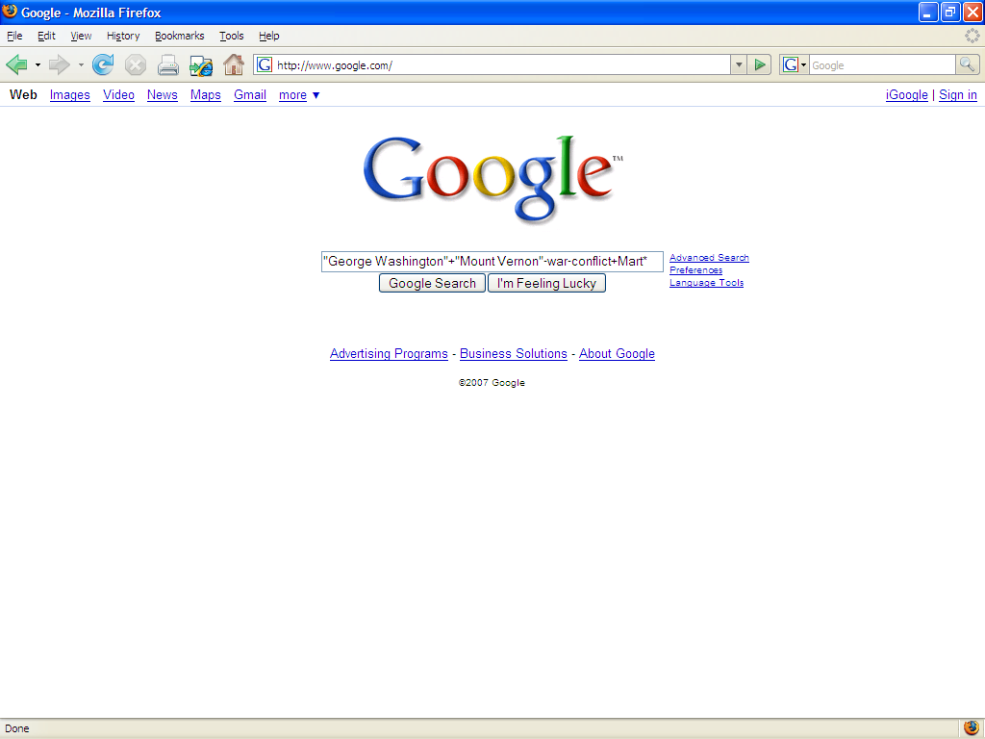

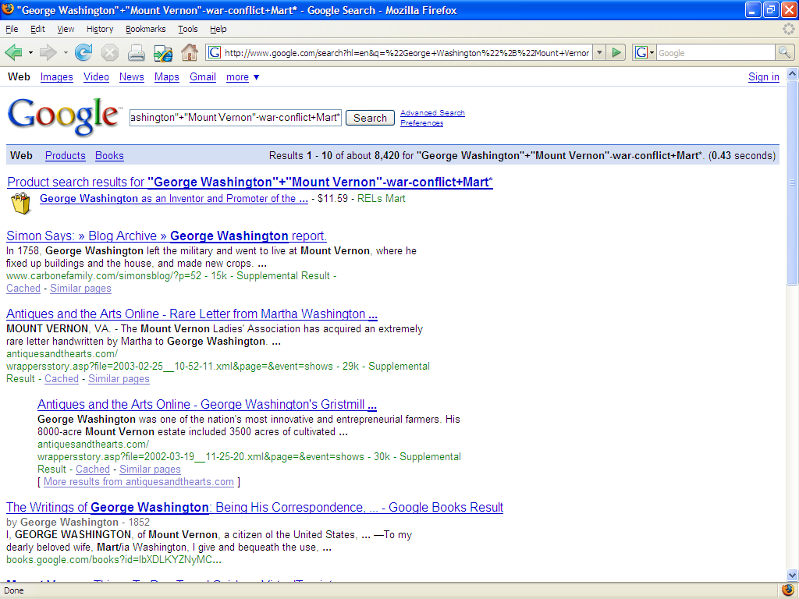

**Refining Options:** Most search engines will allow you to refine your search in the Advanced Options. This is an easier way to search if you are not comfortable using other types of searches.

<http://daphne.palomar.edu/TGSEARCH/>

<http://middletownpubliclibrary.org/tutor.htm>